Discrete Fourier Transform

Continuous FT:

f(t) – real;
F(ω) – complex;

F*(-ω) = F(ω)

Discrete FT:
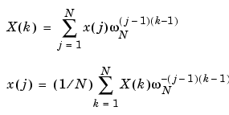

Matlab:
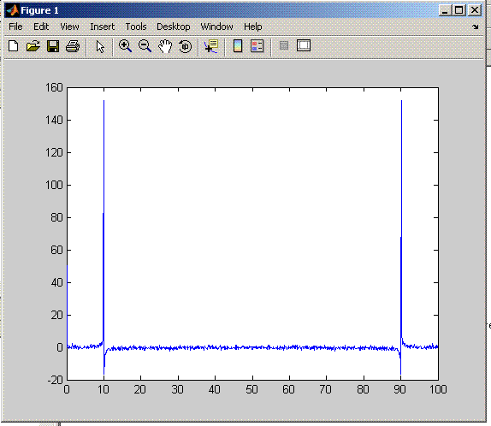
>> t0=0; tfin = 100; dt=0.1;
>> t = (t0:dt:tfin);
>> T = tfin-t0;
>> N = size(t);
>> Nsteps = N(2);

>> f = sin(2*pi*t) + 0.1*rand(N);

>> G = fft(f);

>> plot(t,real(G));

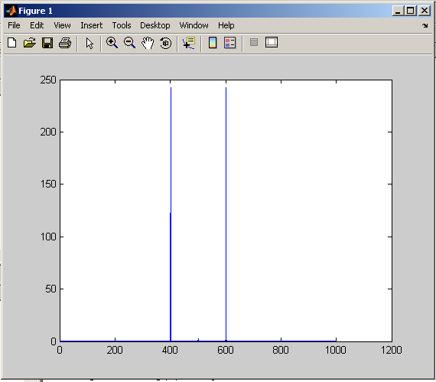
Spectral energy density:

>> GG = fftshift(G);

>> Eomega = abs(GG).^2;

>> plot(Eomega);

Frequencies:

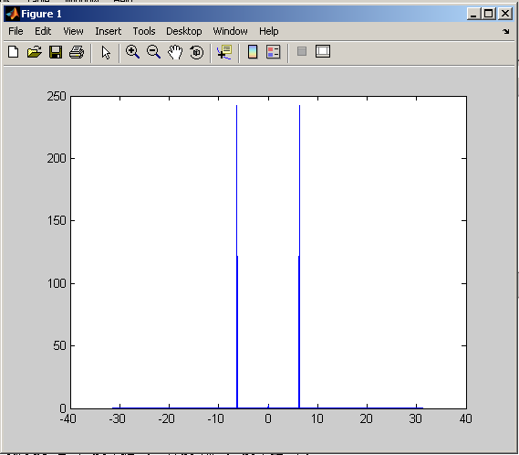

>> omega = (-pi/dt : 2*pi/T : pi/dt );
>> plot(omega,Eomega);
To do:

Matlab Functions:

min
max
size
for / end
if / end
subplot
fft
fftshift
ifft
ifftshift

f(t) = sin(t)*exp(0.2*t) + cos(3*t)*exp(-0.1*t) + 0.2*rand

- Plot E(omega) vs. omega
- Plot Re(F) vs. Im(F)
- G1(omega) = F(omega) + random (physical) noise in phase;
- G2(omega) = F(omega) + random (physical) noise in amplitude;
- plot on single graph: f(t), f1(t), f2(t)

Random noise: Max amplitude = 0.2*Max(F);

F = A*exp(i*phi)
A – Amplitude;
phi – phase;

and

f1 = ifft G1
f2 = ifft G2

- subplot(2,2,1); plot f’(t) vs f(t)
subplot(2,2,2); plot f1’ vs f1
subplot(2,2,3); plot f2’ vs f2

